ENVIRONMENTAL MONITORING SYSTEM

ABSTRACT:

In an era marked by environmental challenges and concerns, the development and deployment of robust environmental monitoring systems have become imperative. This abstract provides an insight into the design and implementation of a state-of-the-art environmental monitoring system that integrates cutting-edge technology to collect, analyze, and disseminate critical data for informed decision-making and sustainable resource management.

The proposed environmental monitoring system leverages a network of sensors, remote sensing technologies, and data analytics to continuously monitor various environmental parameters such as air and water quality, temperature, humidity, and ecosystem health. This sensor network provides real-time, high-resolution data, enabling timely responses to environmental changes and disturbances.

Furthermore, the system incorporates data integration and visualization tools, allowing users to access and interpret the collected data with ease. By providing stakeholders, including scientists, policymakers, and the public, with user-friendly interfaces and comprehensive, up-to-date information, the system fosters a better understanding of the environment's dynamics.

The abstract also highlights the system's adaptability and scalability, enabling its deployment in various environments, from urban areas to remote and sensitive ecosystems. Additionally, it emphasizes the potential for seamless integration with existing monitoring infrastructure and data-sharing protocols, contributing to a more comprehensive and interconnected environmental monitoring network.

Beyond its primary function of data collection and dissemination, the system prioritizes data security and privacy, ensuring that sensitive environmental information is protected and used responsibly.

ENVIRONMENTAL MONITORING INTRODUCTION:

An Internet of Things (IoT)-based environmental monitoring system is a network of interconnected sensors and devices that collect, transmit, and analyze data related to the environment. Such a system can provide real-time information about various environmental parameters, such as air quality, temperature, humidity, water quality, noise levels, and more. Here's an overview of how such a system works and its key components:

1. Sensors and Data Collection:

- Environmental sensors are deployed in the target area to measure specific parameters. These sensors can include:

- Air quality sensors for measuring pollutants like CO2, CO, NO2, and particulate matter (PM2.5 and PM10).

- Temperature and humidity sensors.

- Soil moisture and pH sensors for agriculture.

- Water quality sensors for monitoring water bodies.

- Noise level sensors.

- Light sensors for measuring ambient light levels.

- These sensors continuously collect data and send it to a central hub or gateway.

2. Data Transmission:

- Data from the sensors is transmitted to a central hub or gateway using various communication protocols, such as Wi-Fi, cellular networks, LoRa (Long Range), Zigbee, or Bluetooth.

- The choice of communication technology depends on the range, power consumption, and data volume requirements.

3. Data Processing and Analysis:

- The central hub or gateway aggregates the incoming data and performs basic data preprocessing.

- Data may be sent to a cloud-based platform for more in-depth analysis, where machine learning algorithms can be used to identify patterns and anomalies.

- Data analysis can generate real-time alerts and insights about the environment.

4. Visualization and User Interface:

- Users can access the environmental data through web or mobile applications.

- Dashboards and visualizations provide real-time and historical data, making it easy for users to monitor environmental conditions.

5. Alerting and Notifications:

- The system can be configured to send alerts and notifications when predefined thresholds are exceeded. For example, it can send alerts about high pollution levels, temperature extremes, or water quality issues.

6. Data Storage:

- Environmental data is typically stored in a database for historical analysis, compliance reporting, and trend analysis.

7. Remote Control:

- In some cases, IoT systems may allow for remote control of devices. For example, irrigation systems can be controlled remotely based on soil moisture data.

8. Power Management:

- To ensure continuous operation, IoT devices often incorporate power management techniques, such as low-power modes and renewable energy sources (solar panels, wind turbines).

9. Scalability and Maintenance:

- Environmental monitoring systems can be scaled up or down by adding or removing sensors and devices.

- Regular maintenance is essential to ensure the accuracy and reliability of the system.

10. Use Cases:

- Environmental monitoring systems are used in various applications, including smart cities, agriculture, industrial processes, air and water quality management, wildlife conservation, and disaster management.

Such IoT-based environmental monitoring systems play a crucial role in improving environmental awareness, resource management, and decision-making for both individuals and organizations. They contribute to sustainability efforts and can help address environmental challenges in a more proactive manner.

FLOW CHART:

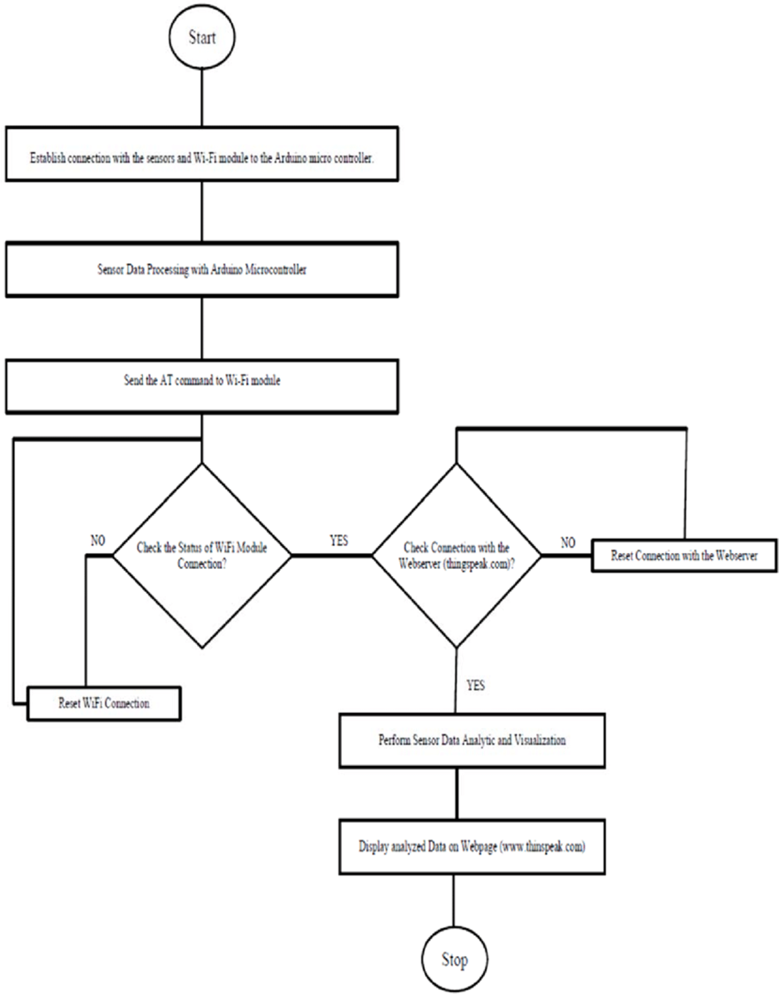

CIRCUIT:

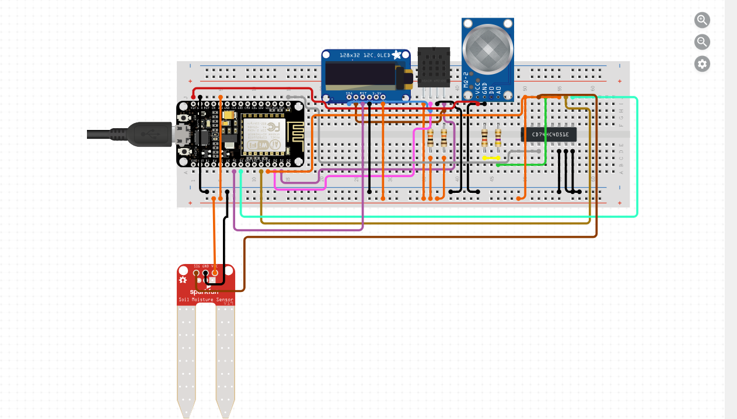

CODE:

// Include Libraries

#include "Arduino.h"

#include "Wire.h"

#include "SPI.h"

#include "Adafruit_SSD1306.h"

#include "Adafruit_GFX.h"

#include "SoilMoisture.h"

// Pin Definitions

#define HC744051_PIN_S0 0

#define HC744051_PIN_S1 2

#define HC744051_PIN_S2 14

#define HC744051_PIN_A A0

#define MQ2_3V3_PIN_AOUT 0

#define OLED128X32_PIN_RST 12

#define SOILMOISTURE_3V3_PIN_SIG 1

// Global variables and defines

// object initialization

#define SSD1306_LCDHEIGHT 32

Adafruit_SSD1306 oLed128x32(OLED128X32_PIN_RST);

SoilMoisture soilMoisture_3v3(SOILMOISTURE_3V3_PIN_SIG);

// define vars for testing menu

const int timeout = 10000; //define timeout of 10 sec

char menuOption = 0;

long time0;

// Setup the essentials for your circuit to work. It runs first every time your circuit is powered with electricity.

void setup()

{

// Setup Serial which is useful for debugging

// Use the Serial Monitor to view printed messages

Serial.begin(9600);

while (!Serial) ; // wait for serial port to connect. Needed for native USB

Serial.println("start");

oLed128x32.begin(SSD1306_SWITCHCAPVCC, 0x3C); // initialize with the I2C addr 0x3C (for the 128x32)

oLed128x32.clearDisplay(); // Clear the buffer.

oLed128x32.display();

menuOption = menu();

}

// Main logic of your circuit. It defines the interaction between the components you selected. After setup, it runs over and over again, in an eternal loop.

void loop()

{

if(menuOption == '1')

{

// Disclaimer: The 74HC4051 - Analog Multiplexer and Demultiplexer is in testing and/or doesn't have code, therefore it may be buggy. Please be kind and report any bugs you may find.

}

else if(menuOption == '2')

{

// Disclaimer: The AM2320 Digital Temperature and Humidity Sensor is in testing and/or doesn't have code, therefore it may be buggy. Please be kind and report any bugs you may find.

}

else if(menuOption == '3')

{

// Disclaimer: The Methane, Butane, LPG and Smoke Gas Sensor - MQ-2 is in testing and/or doesn't have code, therefore it may be buggy. Please be kind and report any bugs you may find.

}

else if(menuOption == '4') {

// Monochrome 128x32 I2C OLED graphic display - Test Code

oLed128x32.setTextSize(1);

oLed128x32.setTextColor(WHITE);

oLed128x32.setCursor(0, 10);

oLed128x32.clearDisplay();

oLed128x32.println("Circuito.io Rocks!");

oLed128x32.display();

delay(1);

oLed128x32.startscrollright(0x00, 0x0F);

delay(2000);

oLed128x32.stopscroll();

delay(1000);

oLed128x32.startscrollleft(0x00, 0x0F);

delay(2000);

oLed128x32.stopscroll();

}

else if(menuOption == '5') {

// Soil Moisture Sensor - Test Code

int soilMoisture_3v3Val = soilMoisture_3v3.read();

Serial.print(F("Val: ")); Serial.println(soilMoisture_3v3Val);

}

if (millis() - time0 > timeout)

{

menuOption = menu();

}

}

// Menu function for selecting the components to be tested

// Follow serial monitor for instrcutions

char menu()

{

Serial.println(F("\nWhich component would you like to test?"));

Serial.println(F("(1) 74HC4051 - Analog Multiplexer and Demultiplexer"));

Serial.println(F("(2) AM2320 Digital Temperature and Humidity Sensor"));

Serial.println(F("(3) Methane, Butane, LPG and Smoke Gas Sensor - MQ-2"));

Serial.println(F("(4) Monochrome 128x32 I2C OLED graphic display"));

Serial.println(F("(5) Soil Moisture Sensor"));

Serial.println(F("(menu) send anything else or press on board reset button\n"));

while (!Serial.available());

// Read data from serial monitor if received

while (Serial.available())

{

char c = Serial.read();

if (isAlphaNumeric(c))

{

if(c == '1')

Serial.println(F("Now Testing 74HC4051 - Analog Multiplexer and Demultiplexer - note that this component doesn't have a test code"));

else if(c == '2')

Serial.println(F("Now Testing AM2320 Digital Temperature and Humidity Sensor - note that this component doesn't have a test code"));

else if(c == '3')

Serial.println(F("Now Testing Methane, Butane, LPG and Smoke Gas Sensor - MQ-2 - note that this component doesn't have a test code"));

else if(c == '4')

Serial.println(F("Now Testing Monochrome 128x32 I2C OLED graphic display"));

else if(c == '5')

Serial.println(F("Now Testing Soil Moisture Sensor"));

else

{

Serial.println(F("illegal input!"));

return 0;

}

time0 = millis();

return c;

}

}

}

CONCLUSION:

In conclusion, the Environmental Monitoring System with IoT project represents a significant step forward in our efforts to address pressing environmental challenges. By harnessing the power of the Internet of Things (IoT), this system provides a comprehensive and real-time solution for tracking and managing environmental data.

Through the deployment of sensors, data collection, and data analysis, the system offers a means to monitor air quality, water quality, temperature, humidity, and other vital parameters. It enables us to gather invaluable insights, detect environmental anomalies, and respond promptly to changes that may impact ecosystems, public health, and the overall well-being of our planet.

The benefits of this project are numerous, from early warning systems for natural disasters to improving urban planning, conservation efforts, and resource management. It empowers individuals, communities, and governments with the information needed to make informed decisions and take proactive measures to protect and preserve our environment.

Furthermore, this project underscores the potential of technology to facilitate sustainable development and create a more harmonious relationship between humanity and the natural world. As we move forward, it is imperative that we continue to invest in and expand upon such initiatives, leveraging IoT and other emerging technologies to create a more resilient and sustainable future for all.

The Environmental Monitoring System with IoT project serves as a testament to the possibilities that lie ahead when we unite innovation, environmental consciousness, and a commitment to protecting our planet. By fostering continued collaboration and investment in similar projects, we can collectively strive to ensure a healthier, cleaner, and more sustainable world for generations to come.